Your catchy title advertising your contribution to the PRN2024
[Arial 14pt bold centered, keep empty 2nd line in case of short titles!]
P. Olymer¹ , R.E. Plication², O.N. Nanoscale^{1,3} [Arial 11pt italic centered]
¹ University of Applied Sciences of Legoland, Günzburg, Germany [Arial 10pt centered]
² Technical University of Nanoland, MicroFab facilities, Microville, France
³ Nanoscale Industries Ltd, Edinburgh, Scotland
Use around half a page for the abstract summarizing the content of your research that you want to present. Ideally, you start with a short introduction of a few lines giving a framework for the experiments and/or theoretical findings that you will report on. [Arial 10pt justified]
Use one or two central paragraphs to discuss the results from your research and highlight some of the findings that will be presented in more detail during the conference. The central part of your abstract should serve as an appetizer for what you must present and does not need to go extremely deep – but can of course. Feel free to emphasize key findings or observations in the abstract and provide a representative illustration accompanying the text. The illustrative figure should represent your work, be well readable and backed up by an explanatory figure caption of maximum 3 lines. Please make sure not to squeeze too much information into the figure – less is often more. References should be cited as [1-3] in the text.
We are very much looking forward to receiving your abstract proposals on your research activities. Thank you in advance for your valuable contribution to the continued success of the PRN conference in its 9th Edition. All abstracts will be rated by the International Advisory Board and the Local Organizing Committee and depending on the rating received will be proposed for oral or poster presentation, respectively. Regardless of the latter decision, the conference booklet will feature all abstracts submitted before the deadline. Please stick to the format of 1-page A4 and convert your abstract into a PDF before submitting it via e-mail as indicated on the website.
Conclude your abstract with a short summary and outlook based on your results. Try to place one take home key message.
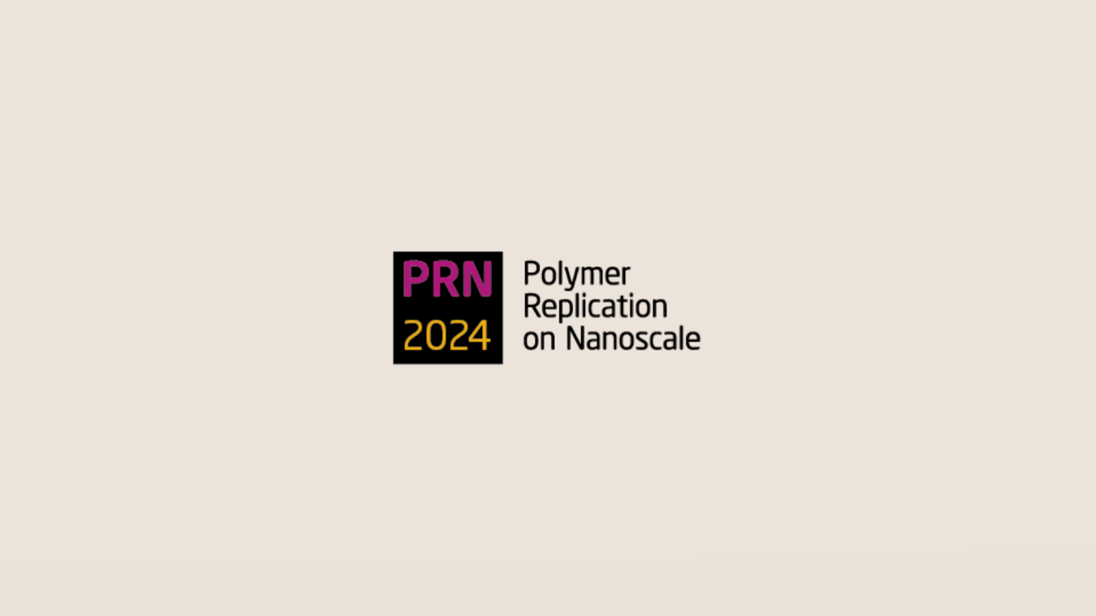
Figure 1: Representative illustration with a sufficiently explanatory figure caption. Try to be concise and avoid lengthy figure captions. Restrict yourself to max. 2-3 lines. [Arial 10pt]
References [give max. 3, Arial 8pt with specified formatting as in the examples below]
1. A. Forner-Cuenca, J. Biesdorf, L. Gubler, P.M. Kristiansen, T.J. Schmidt, P. Boillat, Adv. Mater. 27 (41), 6317-6322, (2015)
2. I. Imhof, E. Müller, P.M. Kristiansen, S. Kresak, L. Tiefenauer, Microfluidics and Nanofluidics, 14 (3), 412-429 (2013)
3. H. Schift, A. Kristensen, “Nanoimprint lithography - patterning resists using molding” in Handbook of Nanotechnology,
3rd Ed.: B. Bhushan, Springer Heidelberg, Germany. ISBN: 978-3-642-02524-2, 271-312 (2010).

